Assignment sheet for IAM

**Assignment1 :- Create an IAM user with username of your own wish and grant administrator policy.**

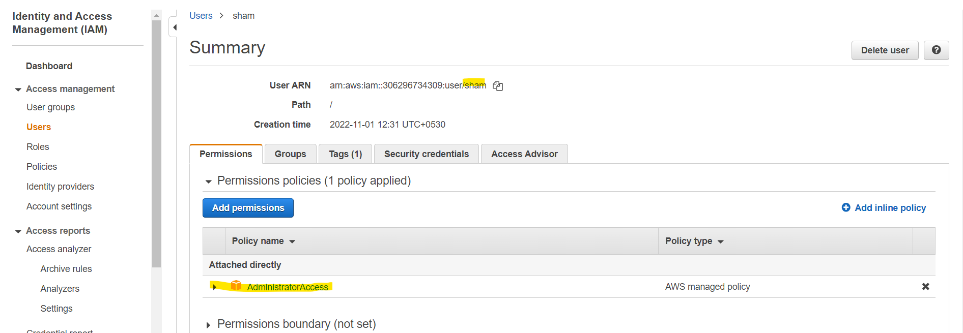

User sham is crated and attached admin access.

**Assignment 2 :- Hello students, in this assignment you need to prepare a developers team of avengers**. 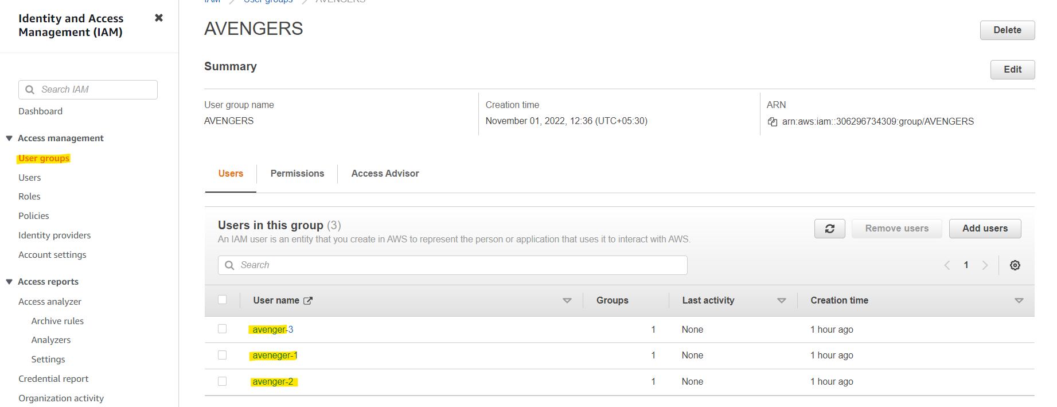

* Created group AVENGERS .

**- Create 3 IAM users of avengers and assign them in developer’s groups with IAM policy.**

* Created 3 users, avenger-1, avenger-2 and avenger-3. Attached developer policy to the group

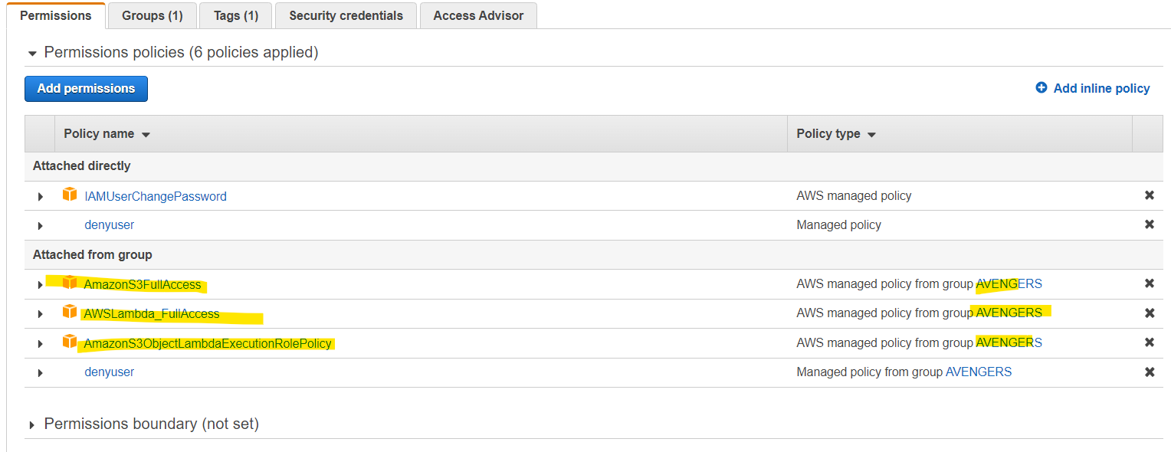

**Assignment 3 :- Define a condition in policy for expiration like "DateGreaterThan": {"aws:CurrentTime": "2020-04-01T00:00:00Z"}, "DateLessThan": {"aws:CurrentTime": "2020-06-30T23:59:59Z"} Define the span of 4 months as per your wish**

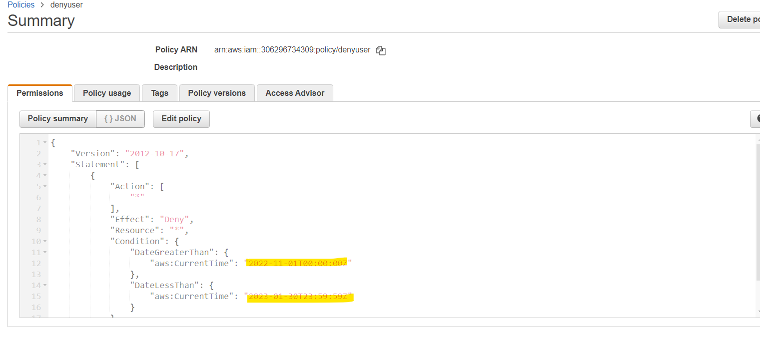

* Defined the policy to expire the user after 3 months and attached to the users

Assignment 4 :- Prepare 15 authentic MCQ questions related to IAM.

**Assignment 5 :- Launch your linux instance in IAM and update your machine.**

* Launch ec2 , assigned ssm role (instance profile) suing ssm. Attached to the instance.
* Connected to the server using ssm connect and then updated the server.

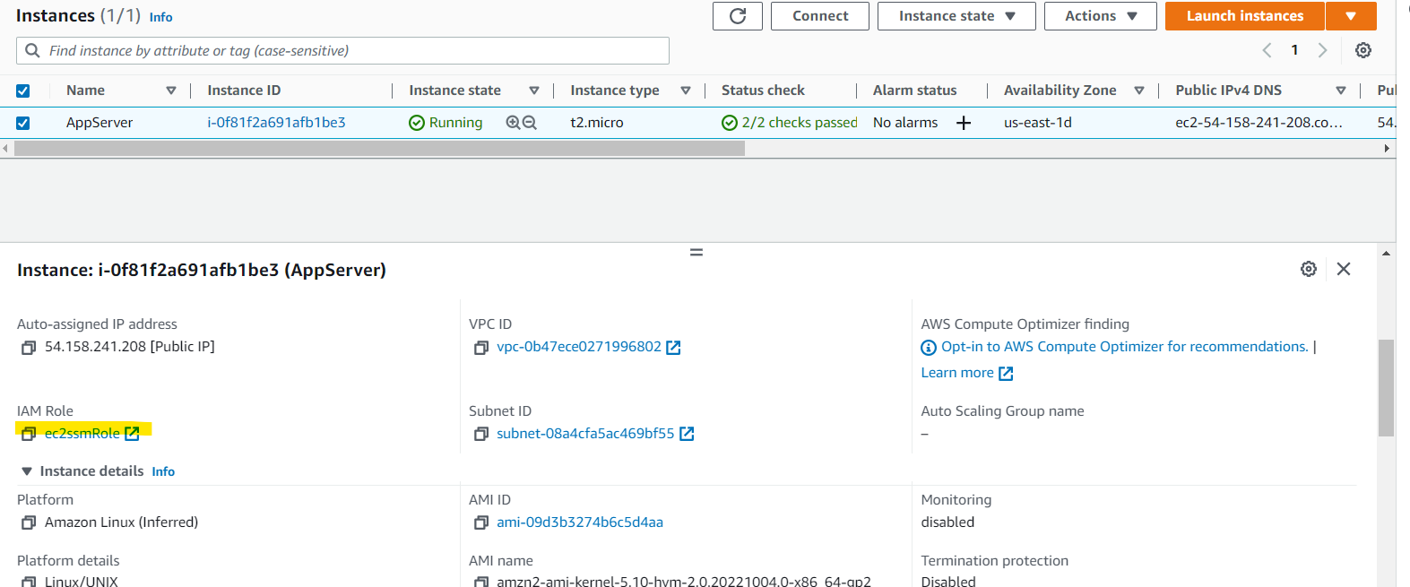

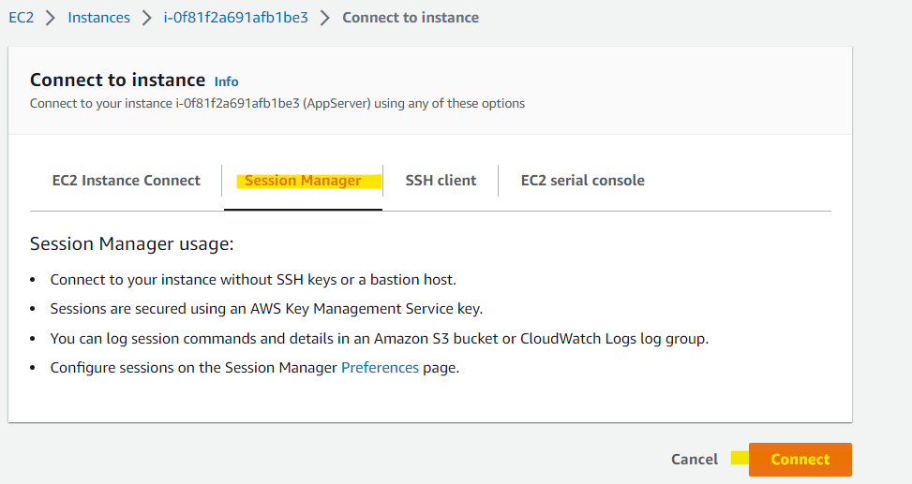

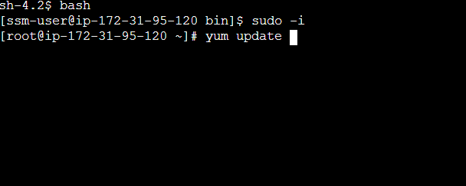

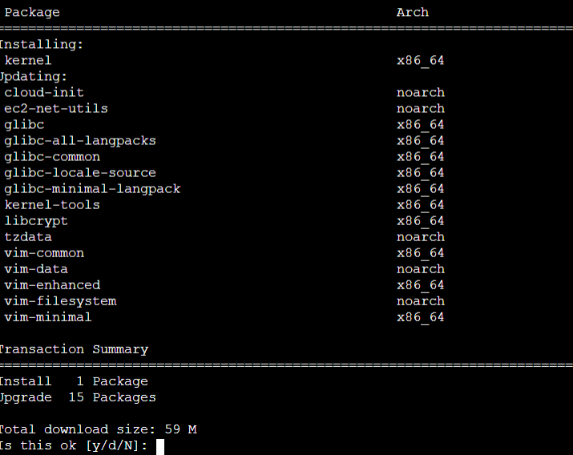

Top of Form

Bottom of Form